EXPERIMENT 2
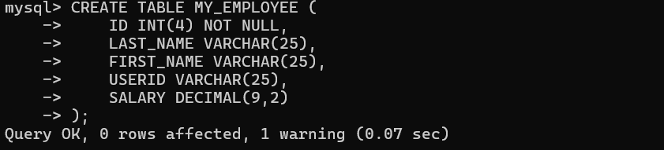
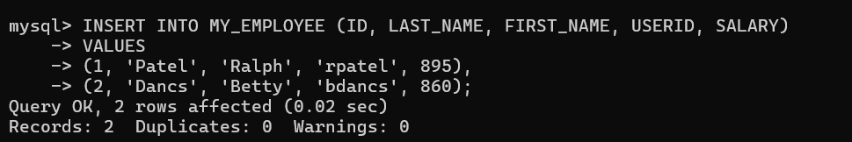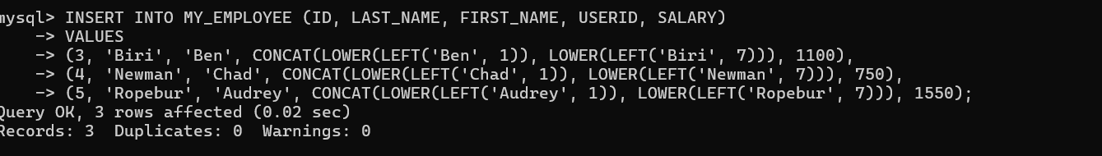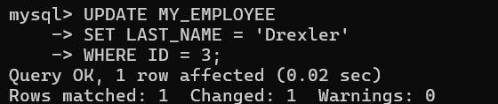

EXPERIMENT 3
